Global YouTube Statistics Data Visualization Report
Siyan LIU
StudentID: 59316283
Data Source
Kaggle: Global YouTube Statistics 2023
Dataset sources URL: https://www.kaggle.com/datasets/nelgiriyewithana/global-youtube-statistics-2023
YouTube is a global online video-sharing platform founded in 2005 and owned by Google since 2006. It allows users to upload, view, like, comment on, and share videos on a wide range of topics, including entertainment, education, news, and personal content. With billions of users worldwide, YouTube serves as a major source of information, entertainment, and digital expression, and it plays a significant role in shaping modern media consumption and influencer culture.
Data Description
The Global YouTube Statistics 2023 dataset comprises a rich collection of performance, demographic, and socioeconomic variables for the world’s top-subscribed YouTube channels. It enables multifaceted quantitative and contextual analyses at the intersection of digital media, creator economics, and global socio-demographics.
Key Variables
The dataset includes channel-level metrics such as:
- Rankings: YouTube channel rank, video views rank, country-specific rank, and channel-type rank;
- Engagement indicators: total subscribers, video views, uploads, and recent activity;
- Channel metadata: Youtuber channel name, Title, category, Country, country Abbreviation, and channel type (individual vs. brand);
- Temporal attributes: created_year, created_month, and created_date.
Additionally, it incorporates country-level socioeconomic indicators, including:
- Population, Urban_population (%),
- Gross tertiary education enrollment (%),
- Unemployment rate,
- Geographic coordinates (Latitude, Longitude).
Monetization estimates are also provided through:
- lowest_monthly_earnings, highest_monthly_earnings,
- lowest_yearly_earnings, highest_yearly_earnings.
Analytical Opportunities
This dataset supports a broad spectrum of empirical investigations, including but not limited to:
- Performance benchmarking: Identifying predictors of subscriber growth and view accumulation across content categories and channel types.
- Regional disparity analysis: Examining how national socioeconomic conditions (e.g., education, urbanization, unemployment) correlate with creator success.
- Temporal trend analysis: Assessing channel growth dynamics and content output patterns over time.
- Earnings modeling: Estimating the relationship between audience metrics (views, uploads) and revenue potential.
- Geospatial mapping: Visualizing the global distribution of top creators and uncovering spatial clusters of digital influence.
- Content strategy optimization: Determining which categories and upload frequencies yield the highest engagement in different regions.
Research Value
Empirical Framework for Digital Influence
The dataset enables quantitative modeling of what constitutes “success” on YouTube—beyond anecdotal narratives—by linking performance metrics (subscribers, views) with creator attributes and macro-level country data.
Cross-Disciplinary Insights
It bridges media studies, data science, economics, and sociology, offering a rare opportunity to analyze how individual agency (e.g., content strategy) interacts with structural conditions (e.g., national education levels) in shaping online visibility.
Actionable Intelligence for Stakeholders
- Content creators can optimize category selection, upload cadence, and audience targeting.
- Brands and advertisers can identify high-potential influencers based on performance trends and regional relevance.
- Policymakers and educators can assess how digital literacy and infrastructure influence participation in the global attention economy.
Visualization Tools
Tableau
Conduct exploratory data analysis using Tableau. Use maps, bar charts, and bubble charts to explore the geographical distribution of top YouTube channels, the differences in uploading, subscriptions, and earnings, as well as the differences in education rates and unemployment rates across different countries. Through this part of the analysis, preliminarily explore whether the subscriptions of YouTube channels are related to their geographical locations.
Python
Data preprocessing was conducted using Python, followed by correlation analysis of the data. Geographical information was integrated with YouTube data, and clustering algorithms were applied to explore differences among various categories of countries. Finally, a heatmap was used to identify correlations between dimensions.
R Studio
Using R to draw a network graph to explore the network relationships between countries and channel categories, thereby identifying the most widely accepted channel categories and countries with diverse (channel category) preferences.
Additionally, a Sankey diagram is plotted to study the conversion relationship between video uploads and revenue.
Descriptive Statistics using Tableau
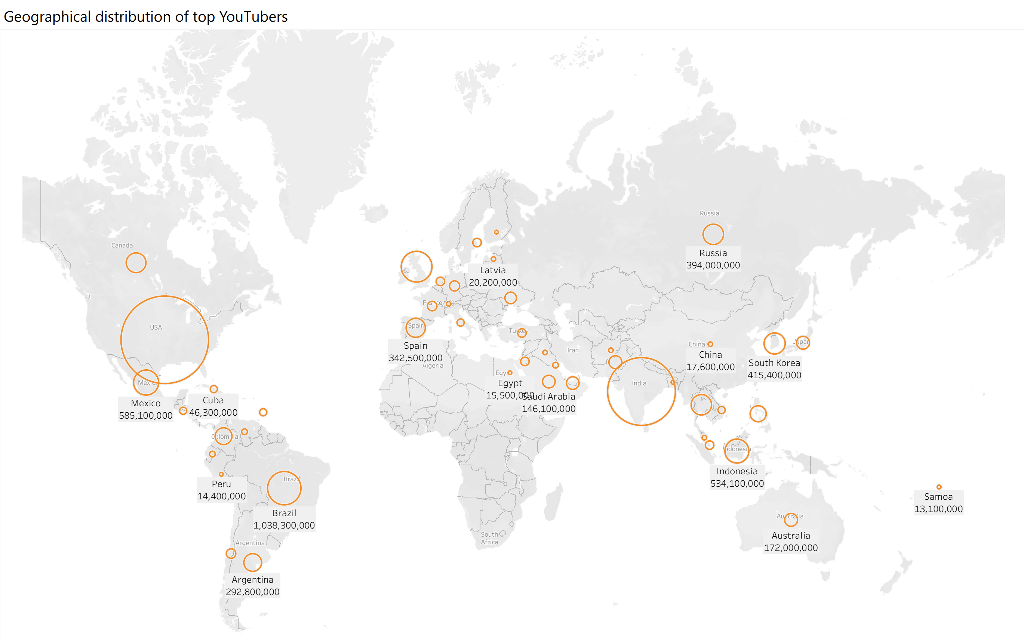
This map illustrates the geographical distribution of top YouTubers around the world, with the numbers representing the sum of subscribers of YouTubers in each country.
In terms of overall trends, there is a clear concentration of top YouTubers in several key regions. Countries like the USA, Brazil, India, and Indonesia have particularly large circles, indicating they have the highest total subscribers.
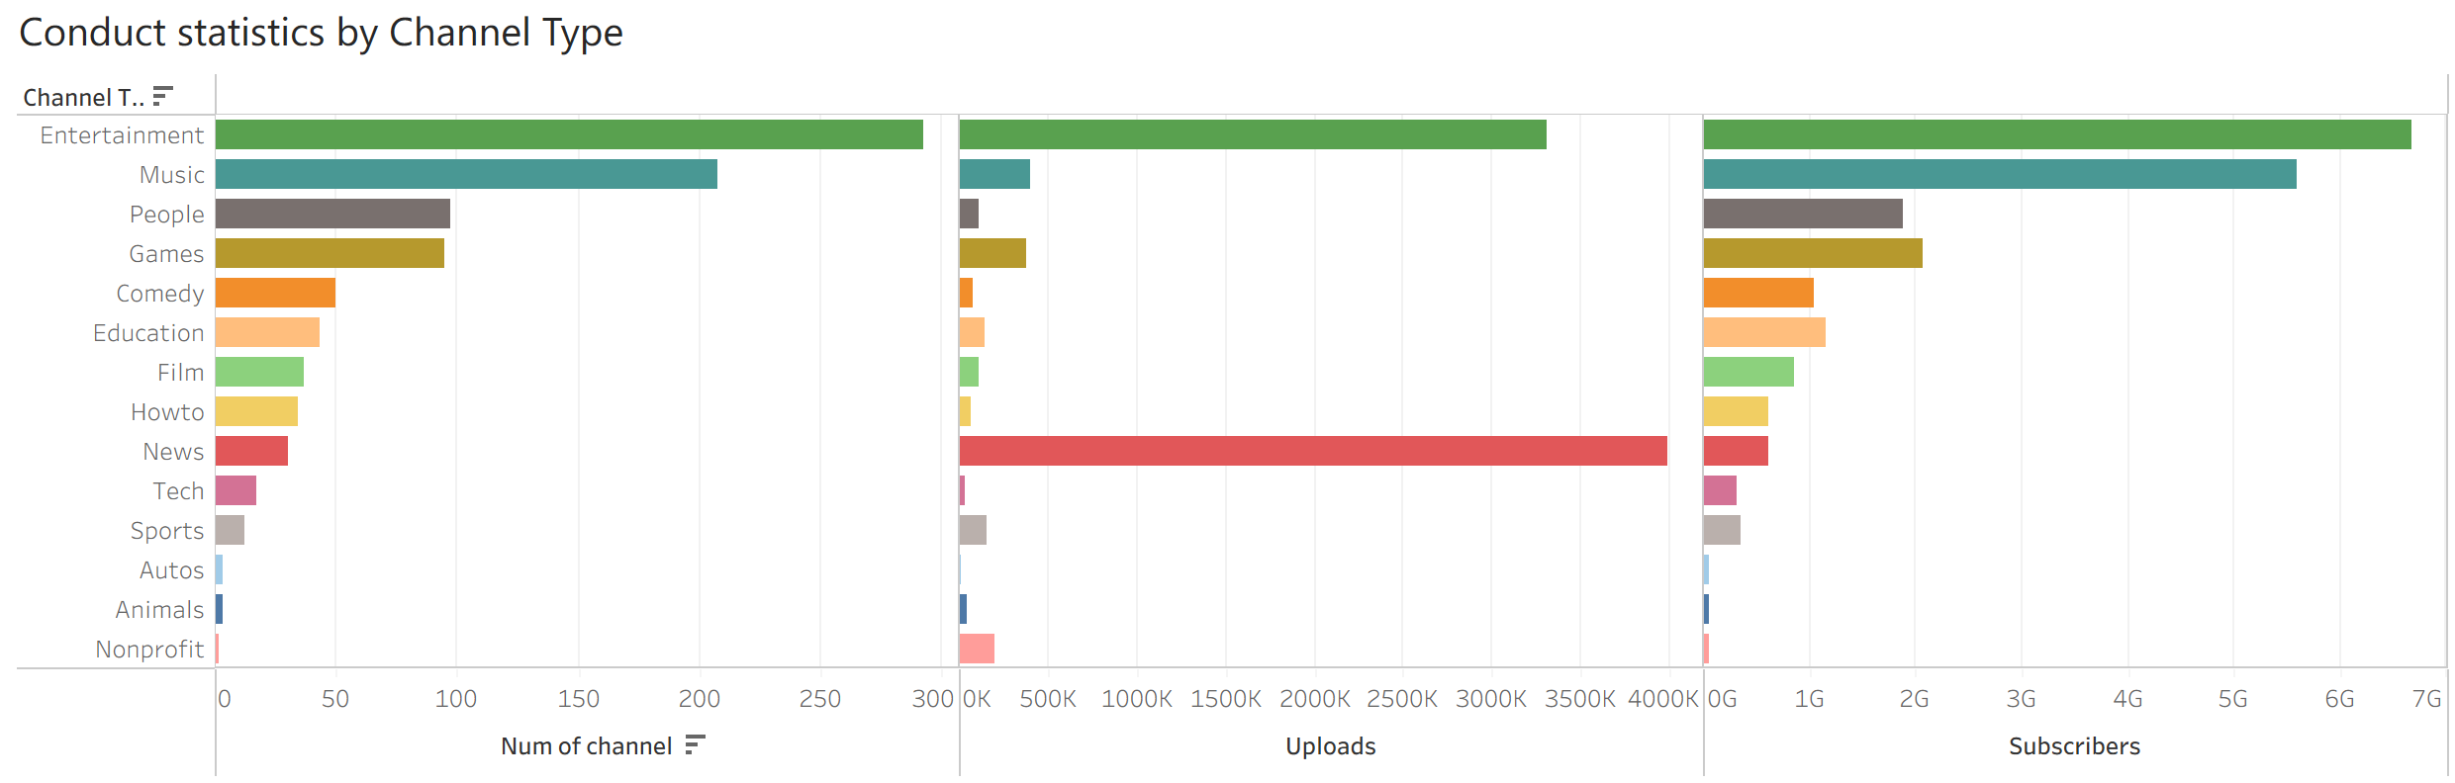
Analyze the differences between various video categories using a bar chart:
- The Entertainment channel type is the clear leader in terms of the number of channels, total uploads, and subscriber count, indicating its dominance on YouTube.
- News channels have a relatively small number of channels and subscribers, they stand out with an extremely high volume of uploads. This suggests a very active content publishing rhythm in the News category.
- Music channels have a moderate number of channels and uploads but boast a very large subscriber count, second only to Entertainment. This shows that Music content has a strong ability to attract and retain audiences.
- Categories such as Tech, Sports, Autos and Animals have very low values in all three metrics, indicating they are much less prominent on YouTube in terms of channel quantity, upload volume, and subscriber reach.
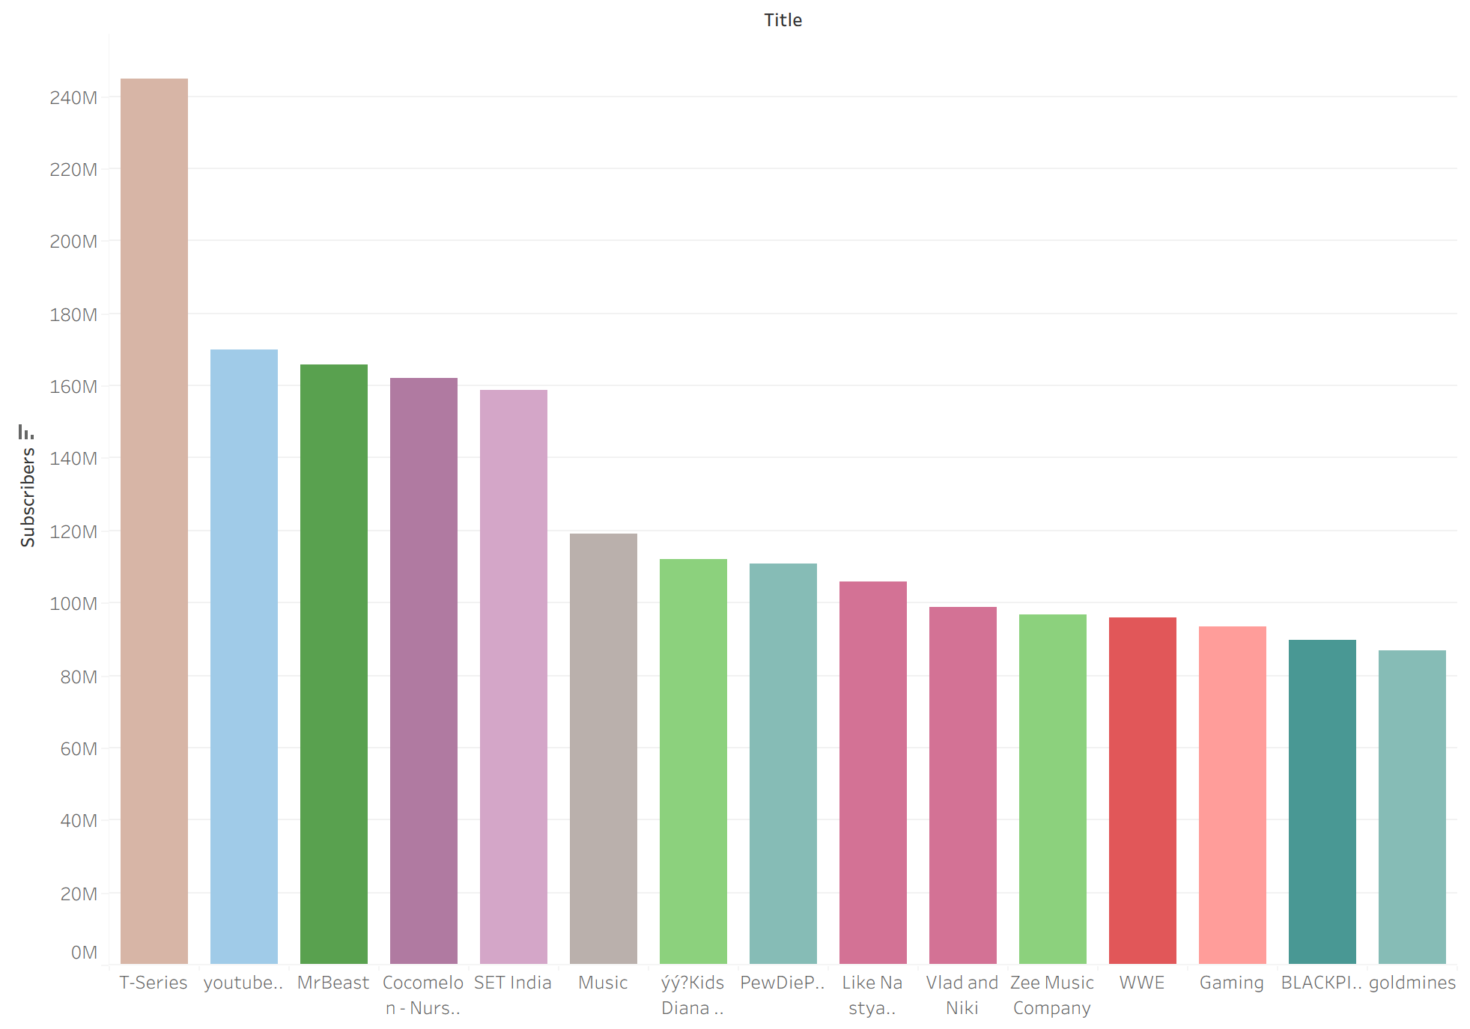
The figure above illustrates top 15 YouTubers by subscribers.
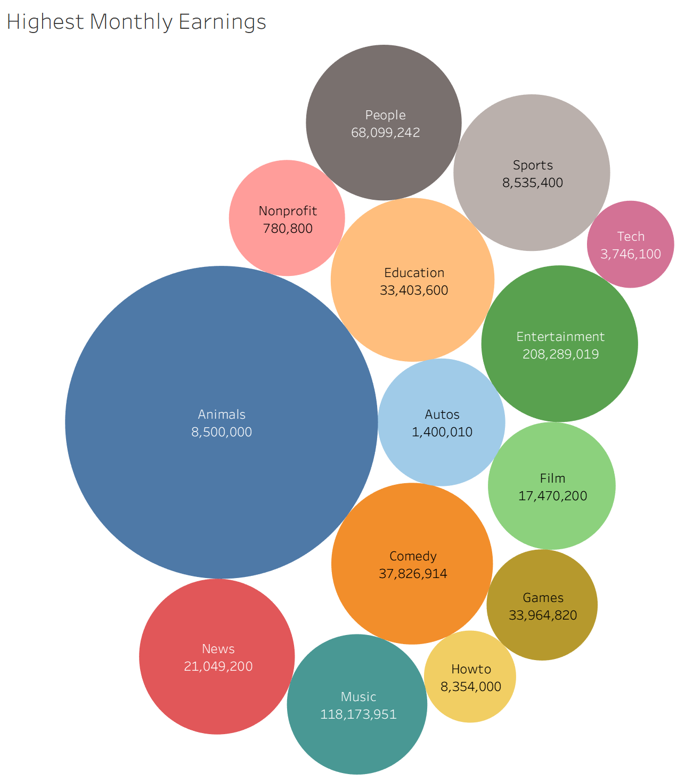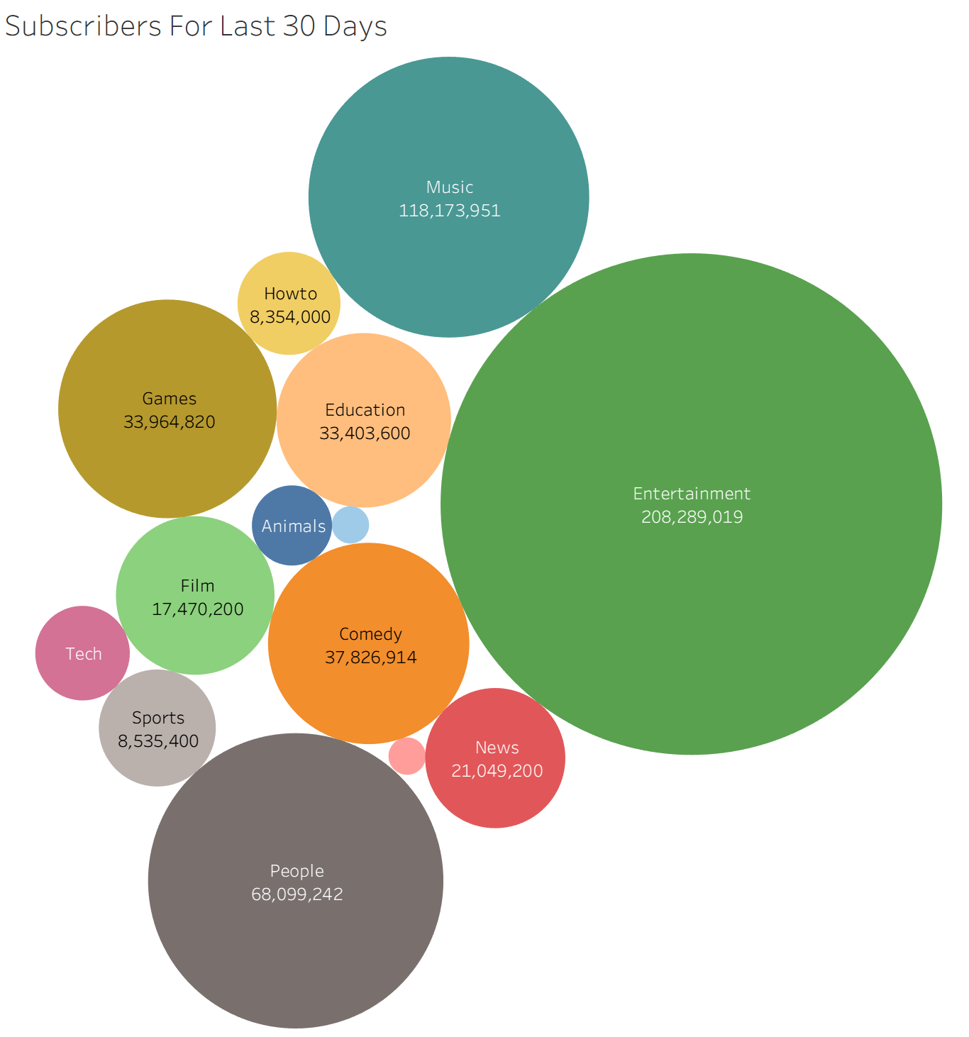
By observing the two bubble charts, it can be found that there is no strong correlation between the number of subscribers and a channel's earnings. For example, animal-themed channels rank low in terms of subscriber count but are the category with the highest monthly earnings.
Animal, education, comedy, and entertainment channels have the highest average monthly earnings. These categories may be more likely to generate advertising revenue or receive payments from subscribers.

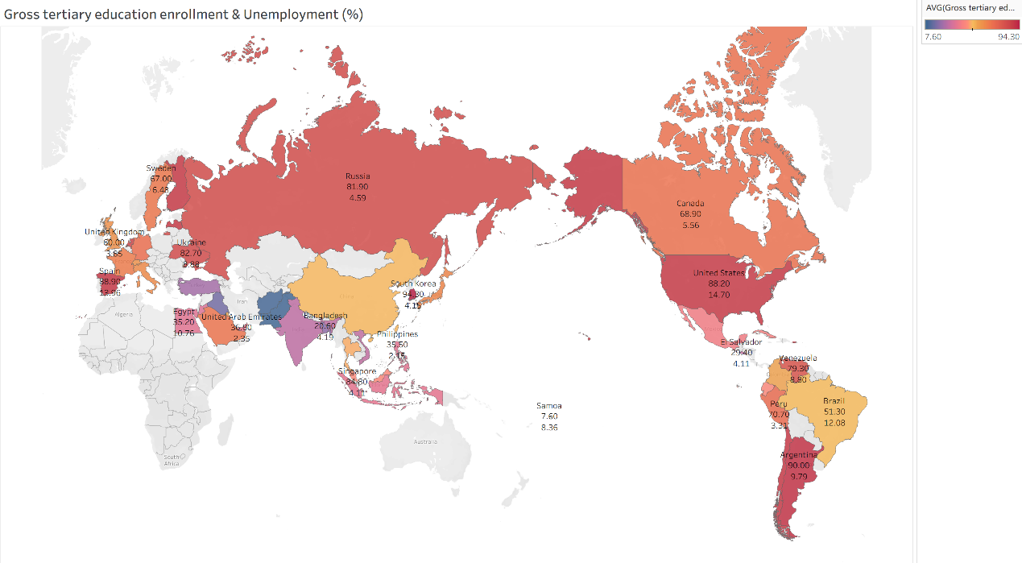
Use map to analyze the tertiary education enrollment rates and unemployment rate of various countries:
- Mixed Correlation Between Enrollment and Unemployment: High enrollment doesn’t guarantee low unemployment (e.g., Argentina: 90.00% enrollment, 9.79% unemployment; US: 88.20% enrollment, 4.70% unemployment). Yet South Korea (94.30% enrollment, 4.15% unemployment) shows strong alignment.
- Regional and Continental Gaps: In Europe, Spain (88.90% enrollment, 15.96% unemployment) vs. Sweden (67.00% enrollment, 6.48% unemployment). In South America, Argentina (90.00% enrollment, 9.79% unemployment) vs. Brazil (51.30% enrollment, 12.08% unemployment).
- Low Enrollment Tends to Link to Higher Unemployment: Bangladesh (20.00% enrollment, 4.19% unemployment) and Samoa (7.60% enrollment, 8.36% unemployment) exemplify this trend.
- Asian Diversity: South Korea/Singapore (high enrollment, low unemployment) contrast with the Philippines (35.50% enrollment, 2.15% unemployment), showing economic structure impacts.
Data Preprocessing and Modeling using Python
Preprocessing
First, we check the dataset and handle abnormal data:
1. Replace obviously incorrect data in the category and channel_type columns with NA;
2. Combine the year, month, and day of channel creation into one column and format it as ‘yyyy-MM-dd’ to facilitate time-series analysis.
Visualization
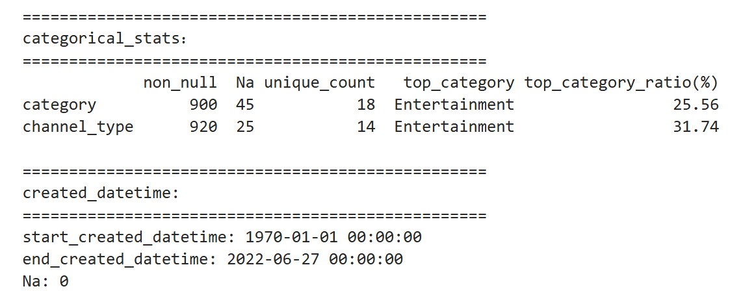
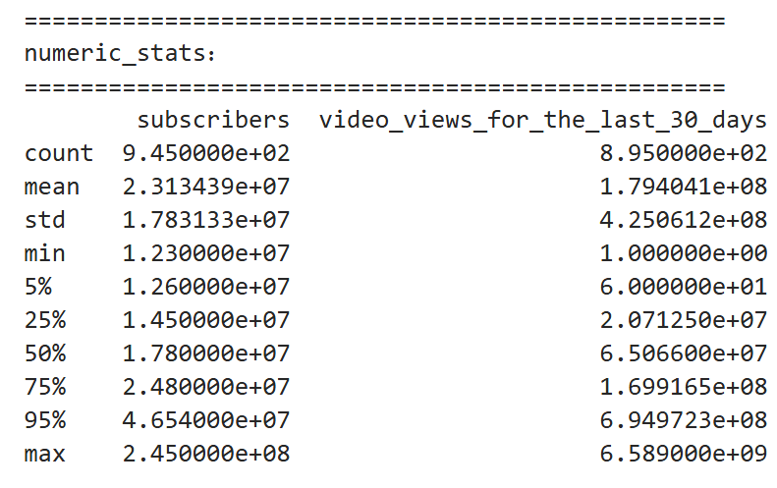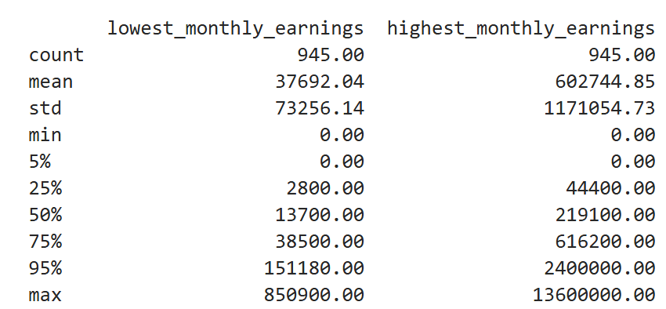
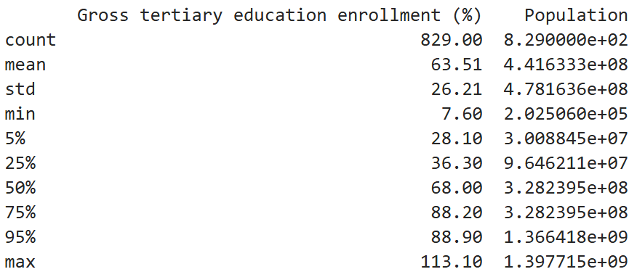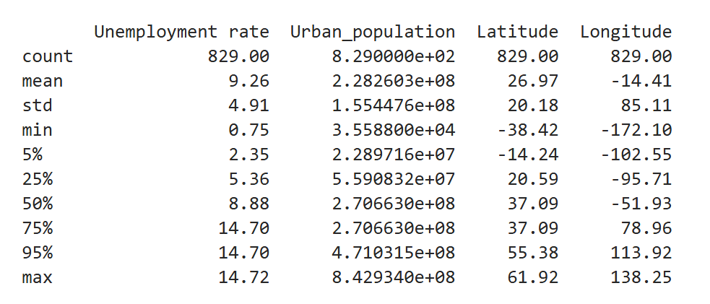
For the processed data, conduct statistical analysis by classifying it into numerical, date, and categorical types.
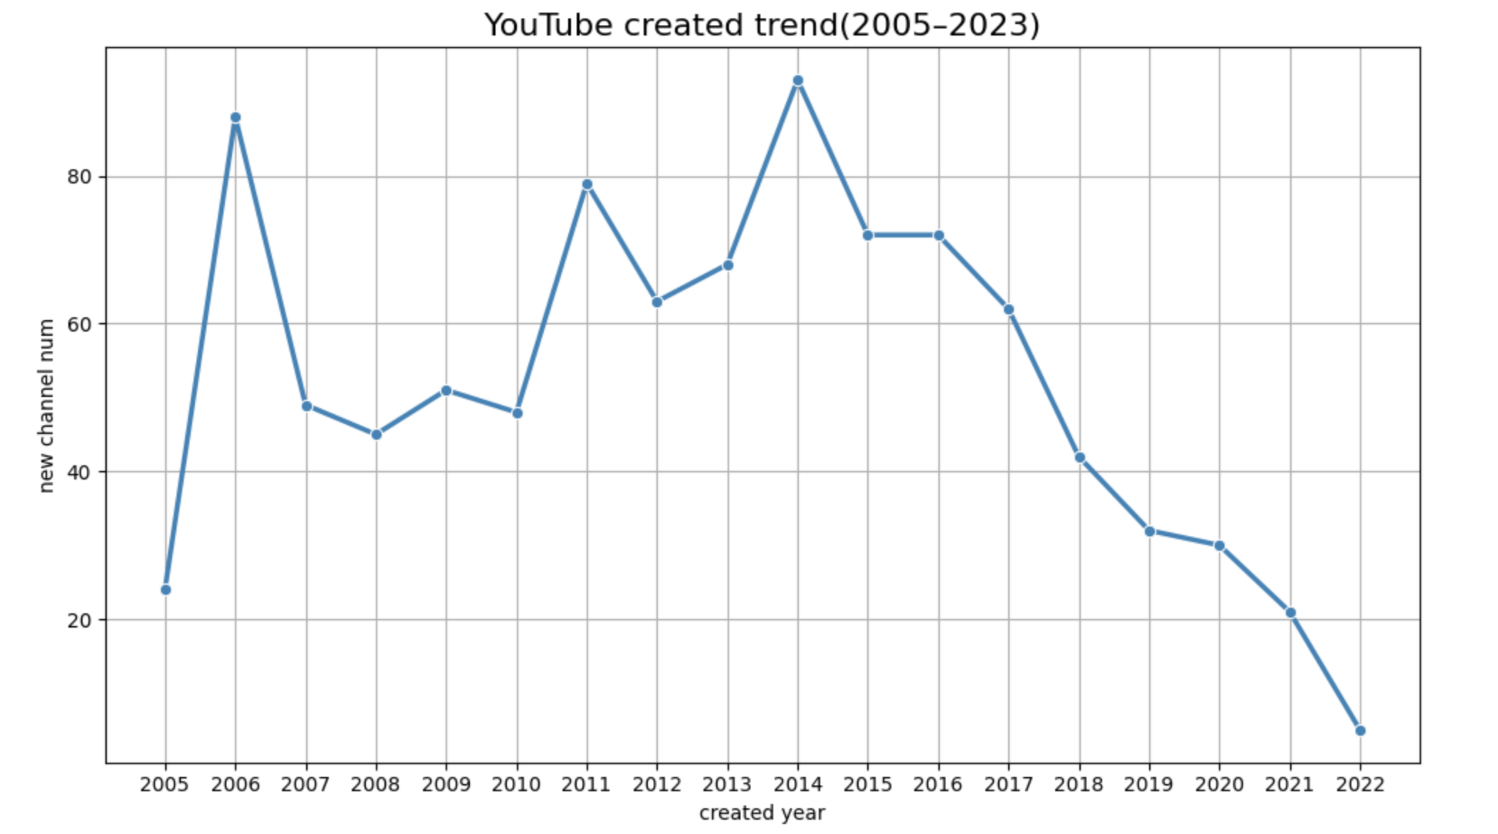
This line chart illustrates the temporal distribution of top YouTube channels by their creation year (2005–2023). The data reveals a pronounced growth phase from 2005 to 2014, peaking in 2014 with over 85 new top channels established. Subsequently, the number of newly created top channels exhibits a consistent and steep decline through 2022, suggesting market saturation or increased barriers to entry for emerging creators in the upper echelons of platform success.
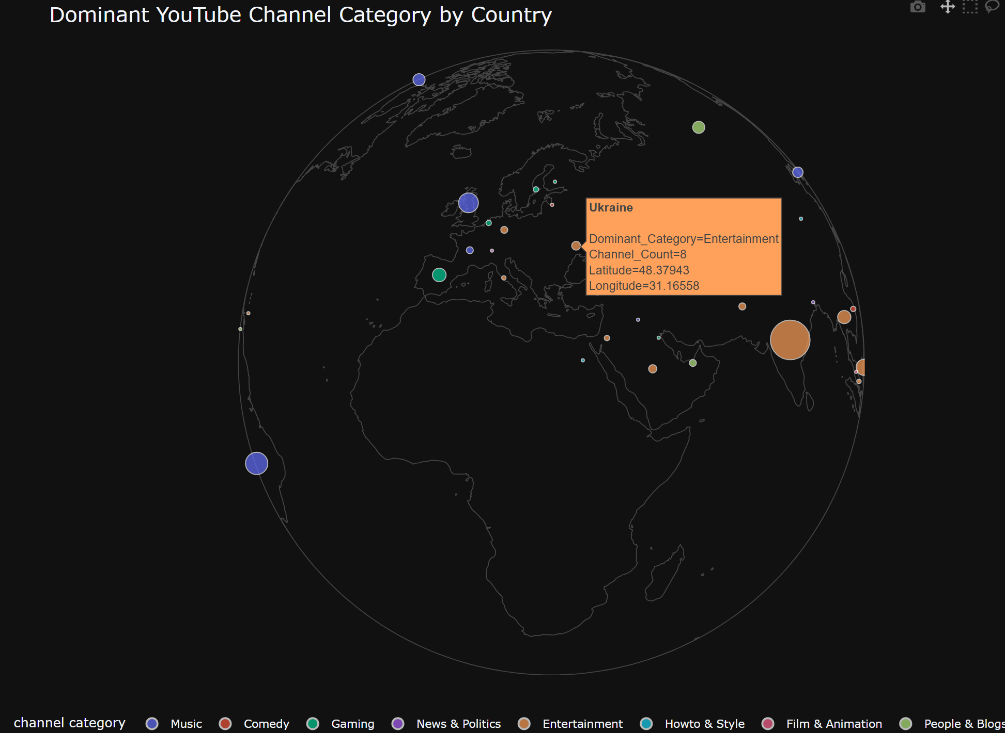
Using the Plotly library, we have created a 3D map that shows the most popular YouTube category for each country.
We have found that, for example, the United Kingdom, France, South Korea, and most American countries prefer watching music-related channels; India and Southeast Asian countries are more fond of watching entertainment channels; China is one of the few countries where the favorite type of videos to watch is the Howto & Style category (Howto videos that provide step-by-step instructions on various topics).
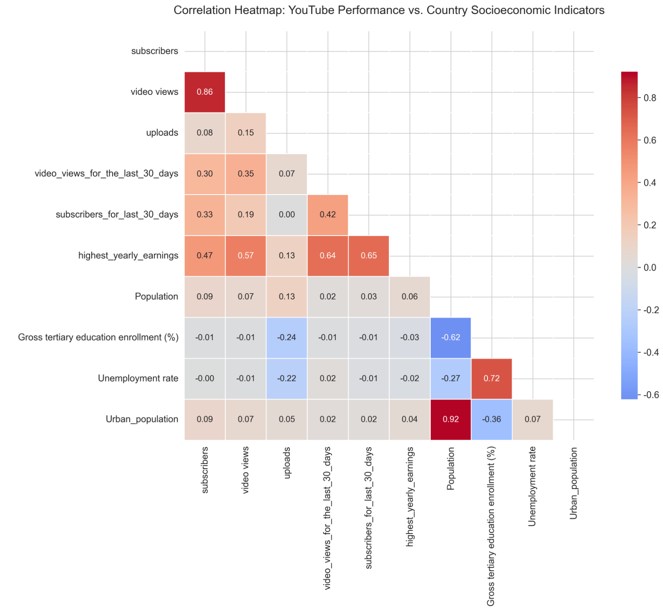
The heatmap shows the correlations between attributes.
Strong Positive Correlations:
- subscribers & video views: Expected — more subscribers usually mean more views.
- uploads & video_views_for_the_last_30_days: Frequent uploaders tend to have higher recent engagement.
- highest_yearly_earnings & subscribers: Monetization scales with audience size.
Moderate Positive with Socioeconomic Factors:
- highest_yearly_earnings & Gross tertiary education enrollment (%): Suggests that top-earning creators are more likely based in countries with higher education levels.
- subscribers & Urban_population: Urbanized nations may have better digital infrastructure and creator ecosystems.
Negative or Near-Zero Correlations:
- Gross tertiary education enrollment rate & population: Countries with large populations find it difficult to popularize higher education.
- Population & subscribers: Surprisingly weak — large population (e.g., India) doesn’t guarantee top-channel success, likely due to income and ad-revenue differences.
Modeling
We used the macroeconomic data of countries to cluster the countries, using K-means algorithm, resulting in three clusters. Based on their characteristics, these clusters are summarized as:
- High-Education / Urban / Low-Unemployment
- High-Population / Low-Education (Emerging)
- Medium-Development / Moderate Urbanization
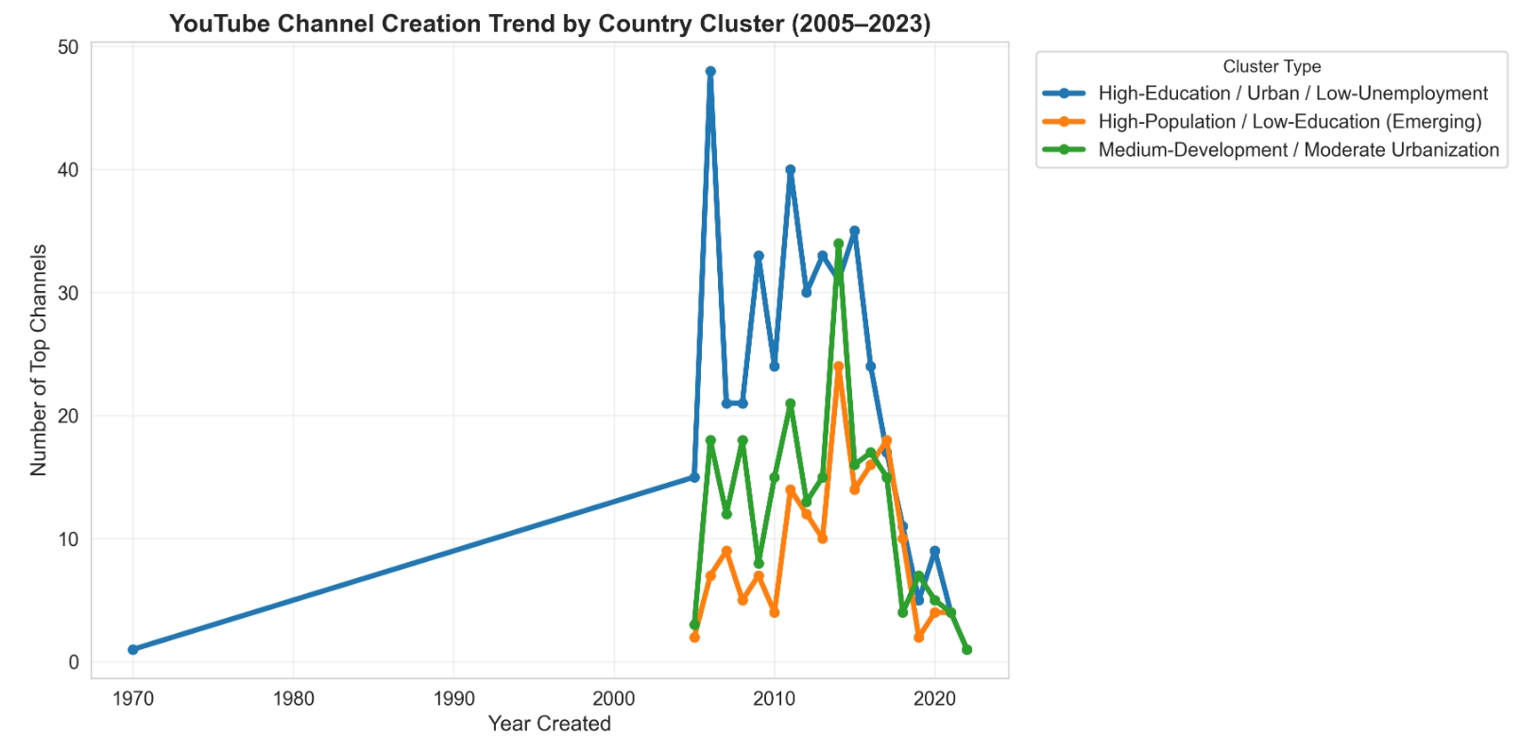
We can see that countries with higher urbanization rates and educational levels play a leading role in the release trends of YouTube.
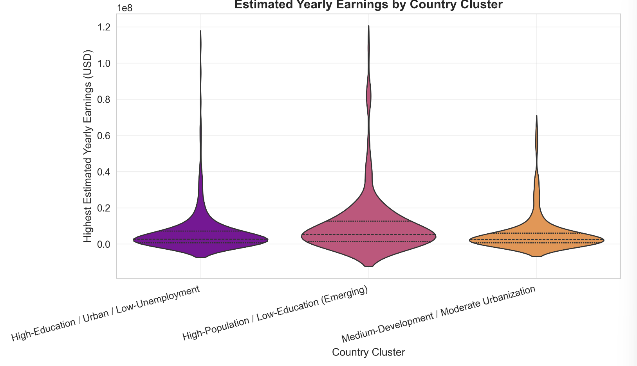
- The distribution of the first group shows a distinct tail at the high-end (> $50M), indicating that a small number of top-tier channels generate extremely high revenues.
- The distribution of the second group is more "flat", which suggests that revenues are concentrated in the low-to-middle range, with a lack of top-tier channels that generate ultra-high incomes.
- The third group exhibits an almost symmetrical bell curve, implying that its revenue distribution is more even—but this also means there is a lack of breakthrough cases of high revenues.
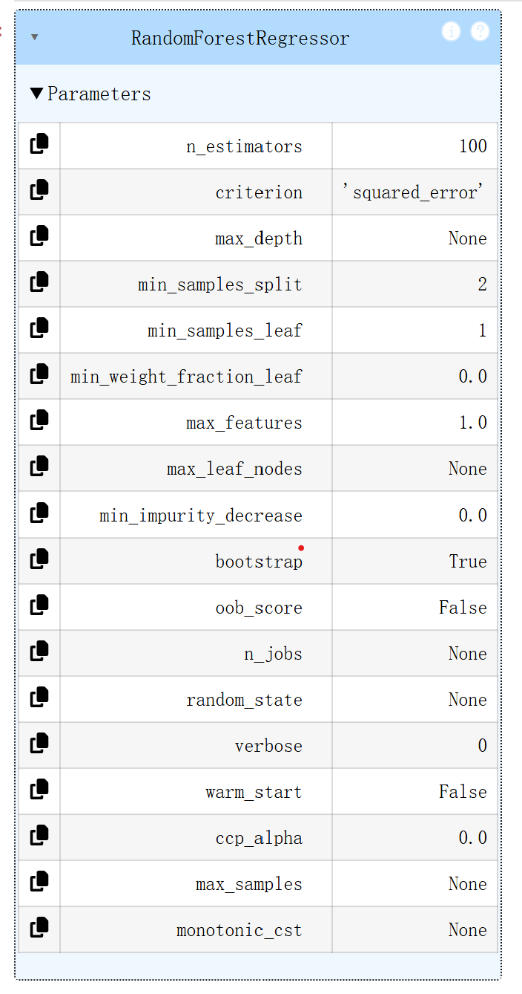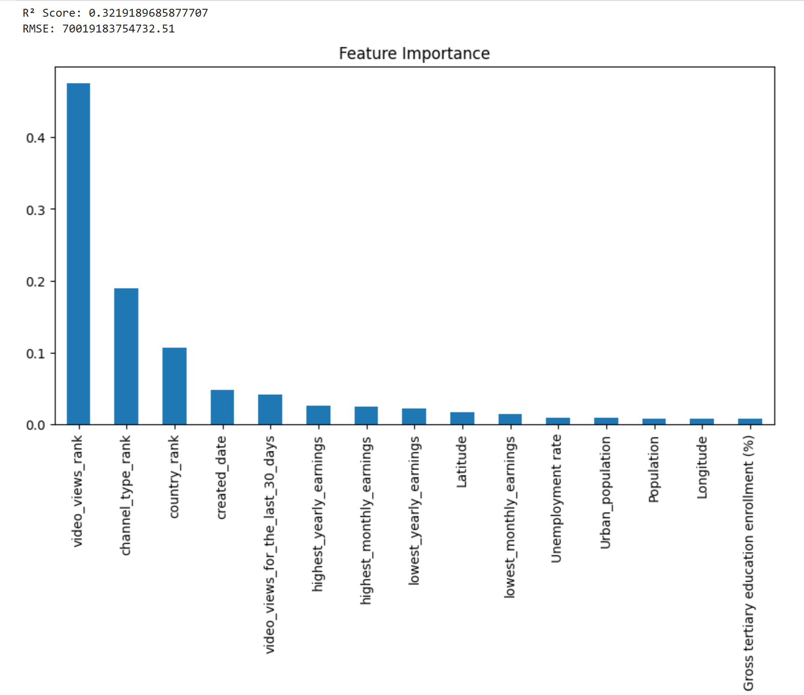
We took the number of subscribers as the prediction target and other variables as influencing factors, trained a random forest model, and explored the features that have the greatest impact on the number of subscribers. We found that the video views ranking has a far greater impact on the results than other features. Secondly, the ranking within this category also has a significant impact on the number of subscribers.
Study of Network Relationships using R
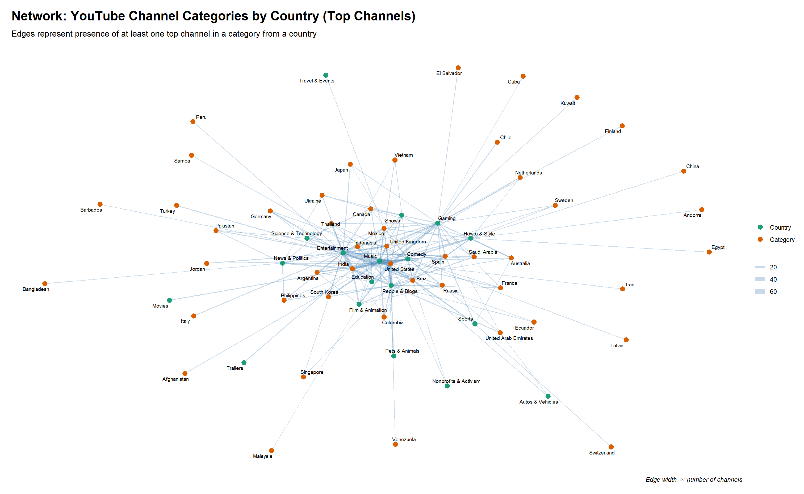
This bipartite network graph reveals the geographic specialization of YouTube content among top channels. Each edge represents the presence of at least one top channel from a given country operating within a specific category.
- Dominance of the United States: US exhibits the highest degree centrality — it connects to the most categories, including Music, Entertainment, Gaming, Howto & Style, and Education. This reflects the US’s role as a global hub for diverse, high-volume content creation.
- Music is the most globally connected category, with links to countries like India, US, UK, Colombia, and South Korea — underscoring its universal appeal.
- Gaming is heavily concentrated in the US, Canada, and Spain, aligning with the global gaming industry’s geographic hubs.
- Education shows broad but moderate connections, suggesting it’s a growing niche with less geographic concentration than Music or Gaming.
Conversion Relationship between Video Uploads and Revenue using R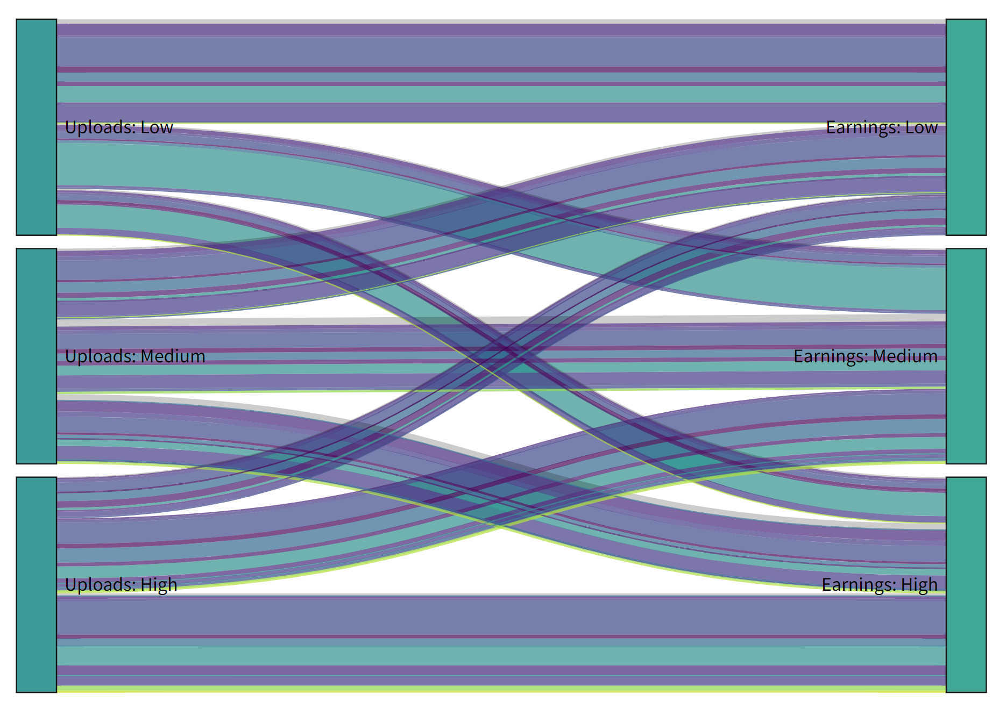
We classified the number of video uploads and video revenue into three tiers (low, medium, and high) respectively, and plotted a Sankey diagram where video categories are distinguished by colors. From the diagram, it can be observed that: most creators who upload a large number of videos tend to achieve high revenue; similarly, the majority of those with a small number of uploads earn low revenue. Video revenue is also related to video quality and the YouTuber’s influence. Therefore, YouTubers should not only maintain a consistent update frequency but also consider how to enhance the appeal of their videos.
Conclusions and Insights
For YouTubers:
- They should choose a niche that suits themselves. For example, they need to consider which category of YouTube videos has a larger audience base and which type of content is more popular among residents in their home country.
- To increase their income, they can publish more content related to entertainment and music. When their subscriber ranking rises, the videos they release are more likely to be viewed, which in turn affects their income.
- Increasing the frequency of video uploads helps maintain the channel's popularity.
For countries:
- They should strive to improve the level of education. When citizens do not have stronger employability, the unemployment rate may increase significantly.
From a global perspective:
- Countries with large populations hold the discourse power on social media (with China being an exception due to policy reasons). For instance, the United States is at the center of the YouTube network graph, with abundant connections—this indicates that powerful countries can also have a stronger voice in cultural aspects, thereby subtly influencing mainstream social opinions.
- In recent years, amid economic downturns, the cultural and entertainment sector has also been on the decline, which can be observed from the trend in the number of YouTube channel creations. Only when the economy is on an upward trajectory are people more willing to participate in cultural activities.

